NSSA-220 Project 1: Application Performance Monitoring
Baden Joseph, Ivan Shao, Kenny Yang

Introduction
Project 1 focused on creating and deploying an application performance monitoring (APM) tool using a Bash script to evaluate process and system-level performance. We were given 6 applications as pre-compiled C executables that needed to be spawned by the script in a Rocky Linux VM. By integrating various diagnostic utilities into the script, we were able to track system resources every 5 seconds for 15 minutes. The APM script would collect the output of all process-level CPU and memory metrics, which was then written into CSV files, while overall system metrics were written into a single CSV file.

Process Level Metrics

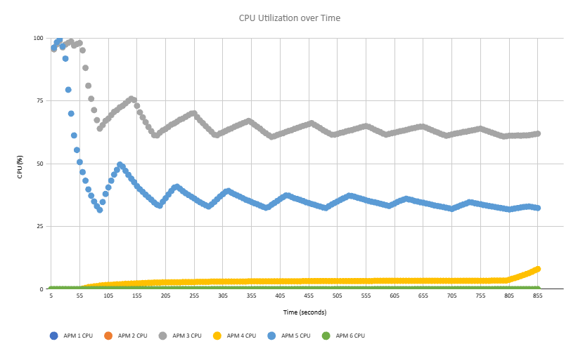

The CPU utilization plot shows 6 processes that were recorded for 15 minutes for CPU utilization. APM1, APM2, and APM6 never registered any CPU usage, while APM4 had a gradual rise in usage to 8% at the end of testing. APM3 and APM5 actually exceeded 100% CPU utilization; they bottlenecked the CPU, which could have throttled the rest of its performance.

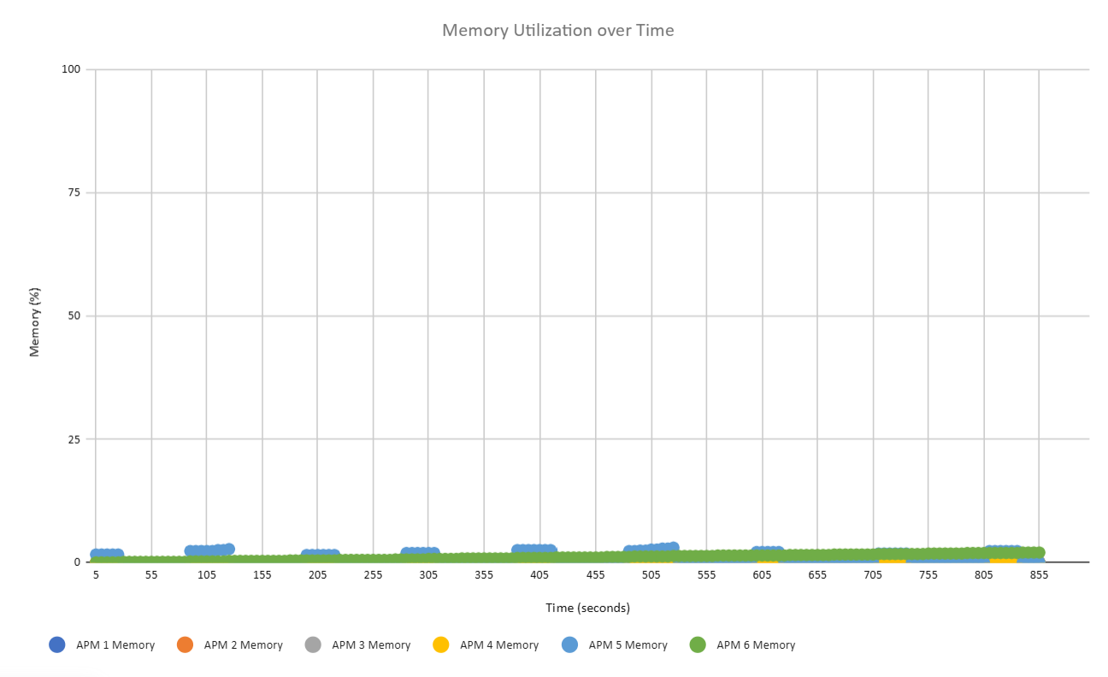

APM1, APM2, APM3, and APM4 never displayed any memory usage. APM 5 would routinely spike to around the 2% mark and drop back to 0%, which indicates relatively normal performance. Now, 6 sees a very slow, incremental increase from 0 to 2, which suggests a potential memory leak as time goes on.

System Level Metrics

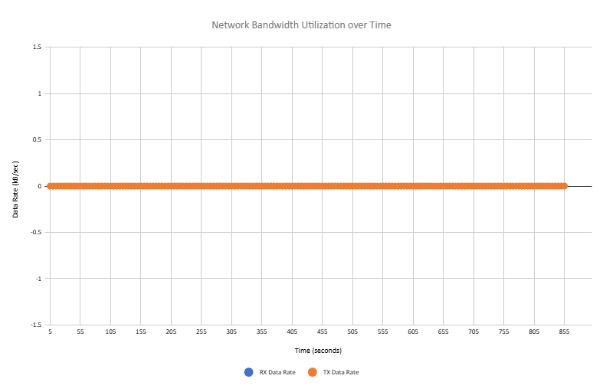
The bandwidth utilization plot demonstrates the data received and transmitted. Because none of the provided executables used any network processes, it remains at 0.

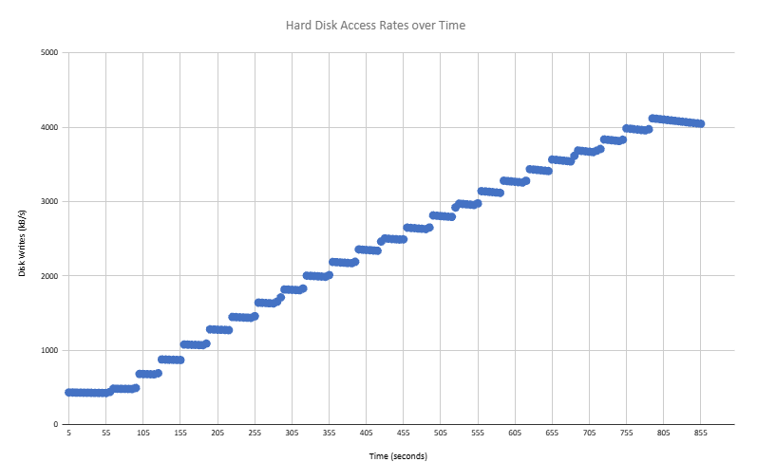

The hard disk access rate plot shows the steady, gradual growth in write activity. In the chart, we can see that gaps are followed by a burst in write speed before slowly decreasing over time, then repeating the process. It started at 432.04 kb/s and topped out at 4119.3 kb/s.

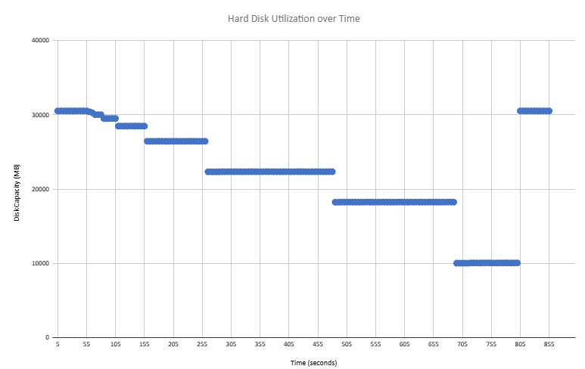

The hard disk utilization plot tracks the available capacity on the root filesystem, showing drops that were generally the opposite of disk write activity. It returns to its original capacity because the APM tool script runs a cleanup function that removes all related processes.

Summary and Lessons Learned
The VM did not have sufficient resources, as the CPU throttled when APM3 and APM5 were running. The APM6 memory leak will eventually exhaust system memory resources if it were running for a prolonged period of time. As a team, we figured out how to divide the work evenly and also learned how important it was to test the code together as a group to make sure that it would run smoothly.

